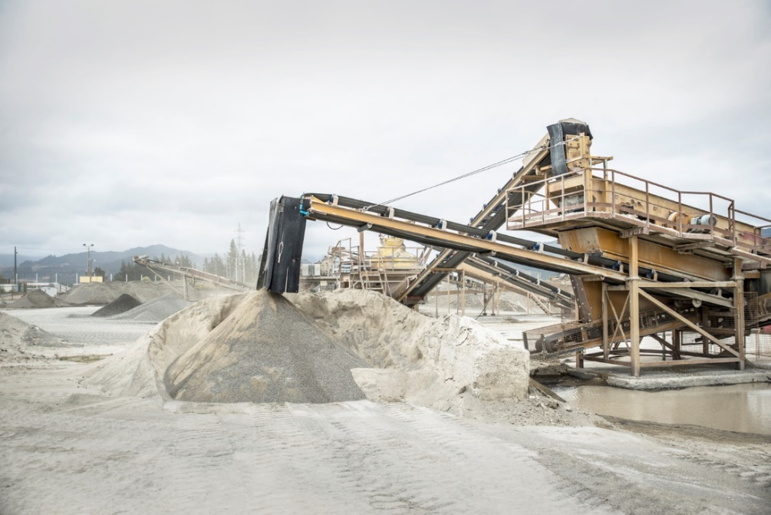
ROCK OUR FUTURE SCHOOL COMPETITION 2021
Expression of Interest Form

Name of School:

Address:

Contact person:

Contact details (email, phone):

Student Name: Year: 5 6 7 8 (please select)

Please return this form to office@aqa.org.nz as soon as possible.

ROCK OUR FUTURE COMPETITION 2021

Overview
Students are to write an essay describing their experiences at a quarry and what they learned.

Task/Curriculum
Students are encouraged to visit a local quarry and write an essay of no more than 500 words describing their experience at the quarry and what they learnt during the visit.

Win money for your school with this exciting project for Years 5-8. Link it to your Technology and/or Science learning.

Design Criteria
Essays are to address the following:
- What was the most interesting thing you learned about at the quarry?
- What are quarry products used for?
- What did you like most about your visit to the quarry?
- What are the main activities at a quarry?
- What improvements could be made at the quarry?
- Any other observations you observe at the quarry

Competition details
- Essays need to be completed by the end of Term Two, Friday 9 July 2021. Please complete the attached Entry Form for each participant and return it with a copy of their essay to the email address on the form. Finalists will be contacted about judging.
- Judging will take place in July/August with winners announced in September 2021.
- Prizes: 4 x prizes of $1,000 for each winning school
4 x prizes of $100 for each of the winning entries

Teachers, parents and students are encouraged to approach local quarries for information and assistance with work on their essay.

Please contact office@aqa.org.nz, or phone 0800 469 272 if you need any assistance in organising a quarry visit in your area.

